Mastersheet - Global Grant
SHARED URL: www.yingtrsef.org/rotary-grant-resources
Acronyms: CG(s) [community garden(s)]; DG (District Governor); GG (global grant); H&W (health and wellness); OCP (Onondaga Lake Partnership); OEI (Onondaga Environmental Institute); POV (point of view); RF (Rotary Foundation); RI (Rotary International); SICRC (Syracuse Inner City Rotary Club);
1/12/17 Conference call - Dessa with Charles Rivers, Cathy Scott, Al Turner and MEW.
- The vision
Creating a template adaptable by RI clubs worldwide that uses community gardens as a sustainable tool to reduce violence and hate crimes by bringing together refugee and longer-resident families and youth in shared food production, opening the door to cross-cultural learning experiences of sufficient depth to launch relationships, improved nutrition, and even long-term garden support through sales of extra crops
- The gardens
Now: Four raised bed CGs at PEACE; youth empowered to conduct research; in April will build raised beds with compost, etc. + planting
With GG: This and other gardens in other Syracuse city sites, all of which incorporate nearby refugee and longer-resident families and youth in shared building, sowing, caring and harvesting of nutritious food, and in cross-cultural learning and celebration.
- Assets:
  - Dessa - Rotary Peace Fellow role emphasizing reduction of violence by using any tools including interpersonal skills; public health POV and credentials; department’s food study unit; emphasis on effective and sustainable strategies; faculty member with 10 yrs of teaching Germany; two faculty members with history of working with CGs who are willing volunteer services; RI prestige of Peace Fellowship and additionally her Fulbright and other honors and roles
  - Charles - PEACE Inc. with site already in place; OEI (30-60 days soil tests for lead, etc.) for youth-led CGs with support of gardening clubs such as Syracuse Grows, Onondaga Creek Partnership; Wegmans as eager partner for 2017 Extravaganza expansion; County Health Dept looking for H&W connection, too (March 10th OnCenter event with a coordinator eager to connect with H&W in August)
  - Al - Food Co-op Board opportunity (Brady Faith is doing soil analyses to qualify to sell products to coop!); 100 Black Men (one of their pillars is health and wellness! Chaired by Charles Manson) would be seamless connection; access to OnPoint youth as interns or other participation would need to be routed through their management
  - SICRC - TLC connections to other CGs and potential sites for CGs (St. Lucy’s, Northside park); commitment from local fund to provide interest-free loan to front expenses to be reimbursed by RF and other sponsors
  - MEW - Interfaith Works Community Dialogues and Dialogue Dinners; visits to German RI groups, coordinated with Dr. Bellows and her contacts; initial web hosting (to be taken over by knowledgeable partner ASAP)
- Whom and how we can serve
  - Huge refugee population at Central Village but not a lot of support
  - Incoming and recently-arrived refugees through Interfaith Works
  - Dessa - ask for their input and suggestions for traditional supports and crop choices (advisory teams?)
  - Cathy - take advantage of good intro to other cultures via food, so each culture brings its key crop to the garden, too, introducing cultural basics to fellow gardeners and to neighborhood
- Tasks
  - Dessa - help create a template useable across cultural/country lines (“cultural bridging”)
  - Charles - monitor issues of neighborhood barriers (pockets where people feel unsafe, lines people fear crossing) for refugee and longer-resident folks; serve as current link to Food Bank’s Food Smart sustainability resources, OEI testing/monitoring/training, OCP youth, PEACE network of centers and services; Wegmans (Note: When the grant team is built, other people should take the lead on each of these, both to empower those individuals to advocate for themselves and to let Charles have time to run his Center.)
  - Al - connect project with Food Co-op, 100 Black Men, possibly OnPoint
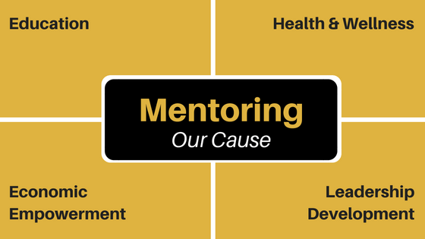
TASKS by Wednesday:
Al get details on parameters to qualify to sell produce
talk with 100 Black Men leadership re connection via pillars
Dessa ID and provide connections with faculty/staff partners
MEW Better organize website and load with needed resources
Get DG Peter on board to advocate and network
Cathy Please consider issues of liability that we should consider in case it comes up on Wednesday
Charles Review partners cited above and ID others we’ve missed that you already have on board

